**1. What is DAM and Why Do We Use It?**

**DAM (Digital Asset Management)** is a system within AEM that allows organizations to store, organize, manage, and retrieve digital assets like images, videos, and documents efficiently.

**Why Use DAM?**

* Centralized storage for digital assets.
* Easy retrieval and reuse of assets across projects.
* Automated workflows for image processing and metadata management.
* Supports renditions for different device resolutions.

**2. Create one folder inside our project folder and follow the path: “/content/dam/myTraining/us/en-us” and upload 2 images and author those images on page using image component as we see today.** 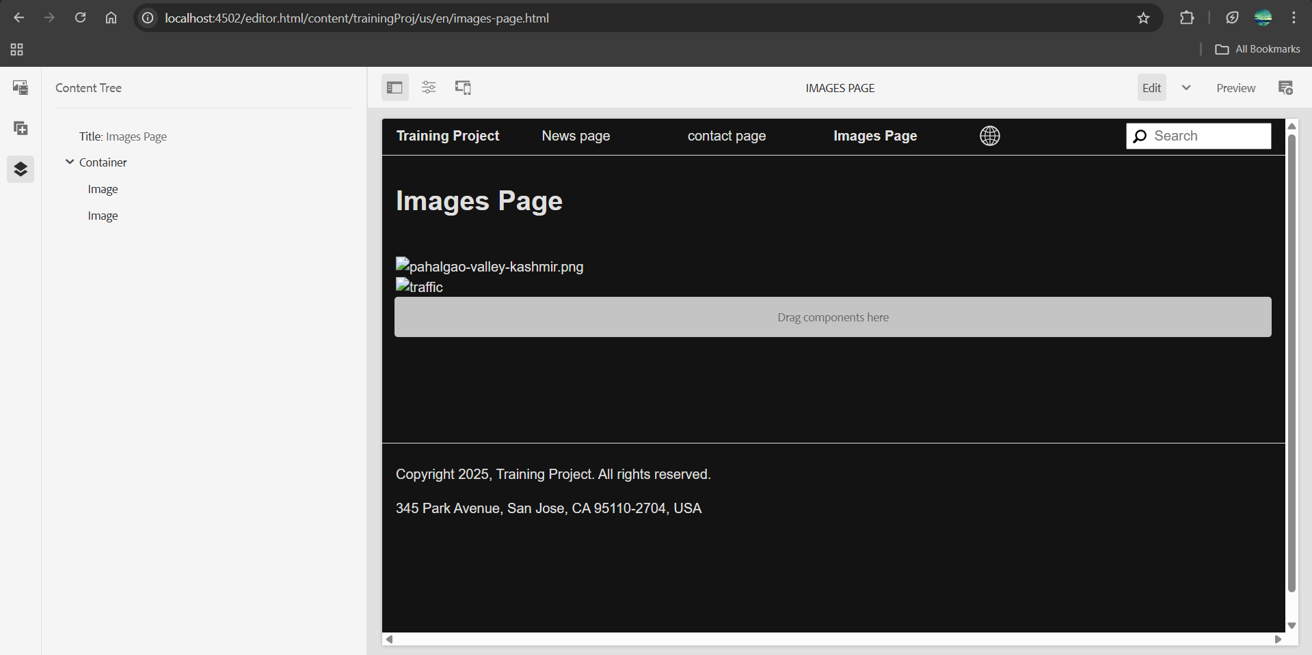

**3. What is renditions? Check the renditions for 2 images which we had uploaded**

Renditions are automatically generated versions of an asset (image, video, document) in different sizes and formats when uploaded to AEM DAM. These renditions are used to optimize performance and support different use cases like thumbnails, previews, and responsive images.

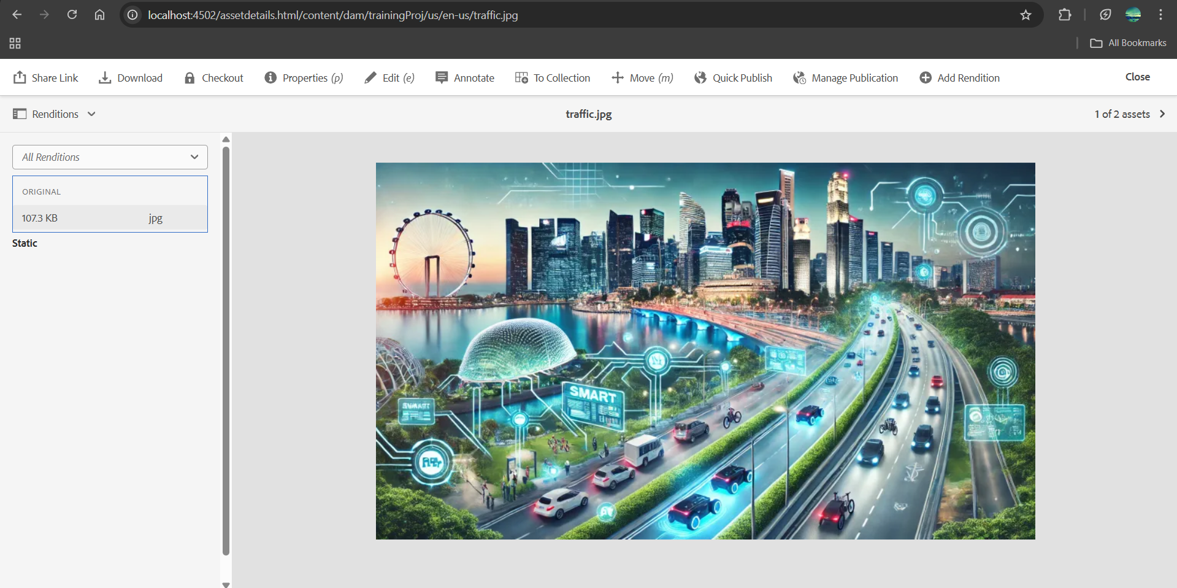 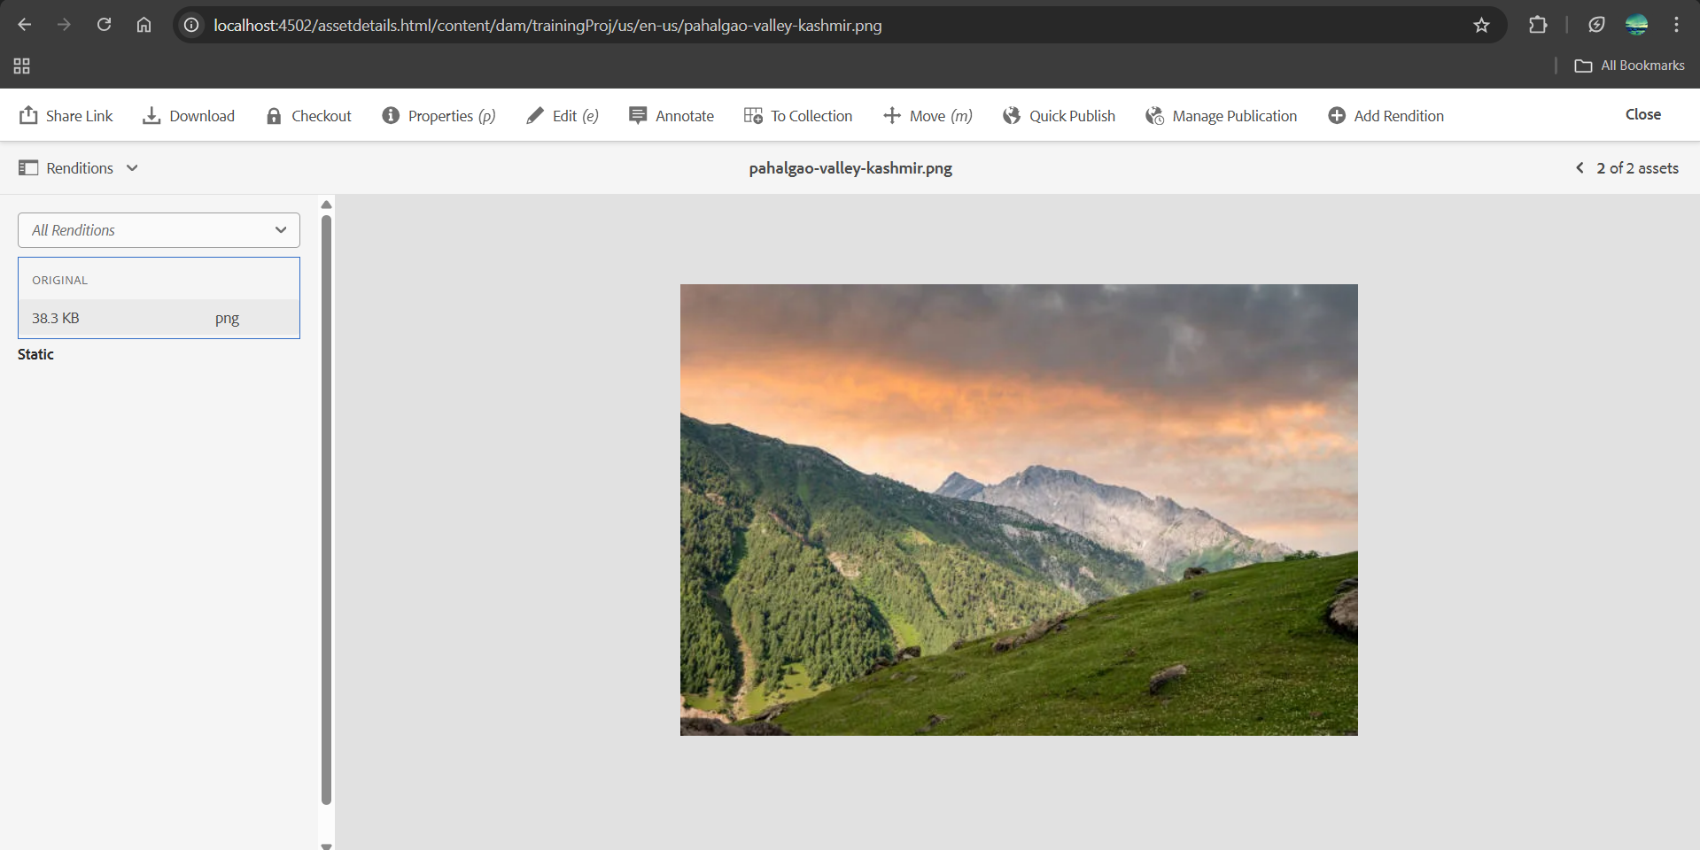

**4. Add two fields in hello world component with name FirstName and Last Name and print the values on hello world.html component using properties**

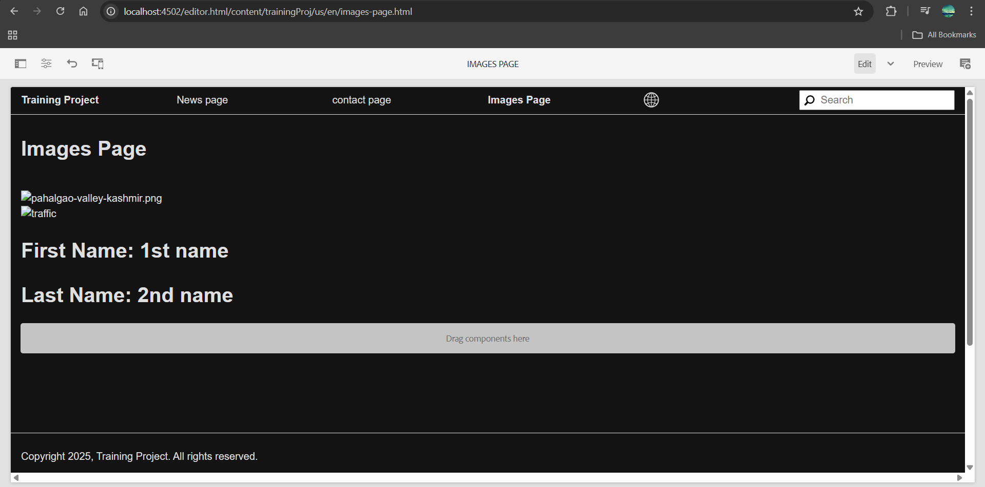

**5. Give try using @ValueMapValue annotation on HelloWorldModel sling java model “com.myTraining.core.models.HelloWorldModel”**

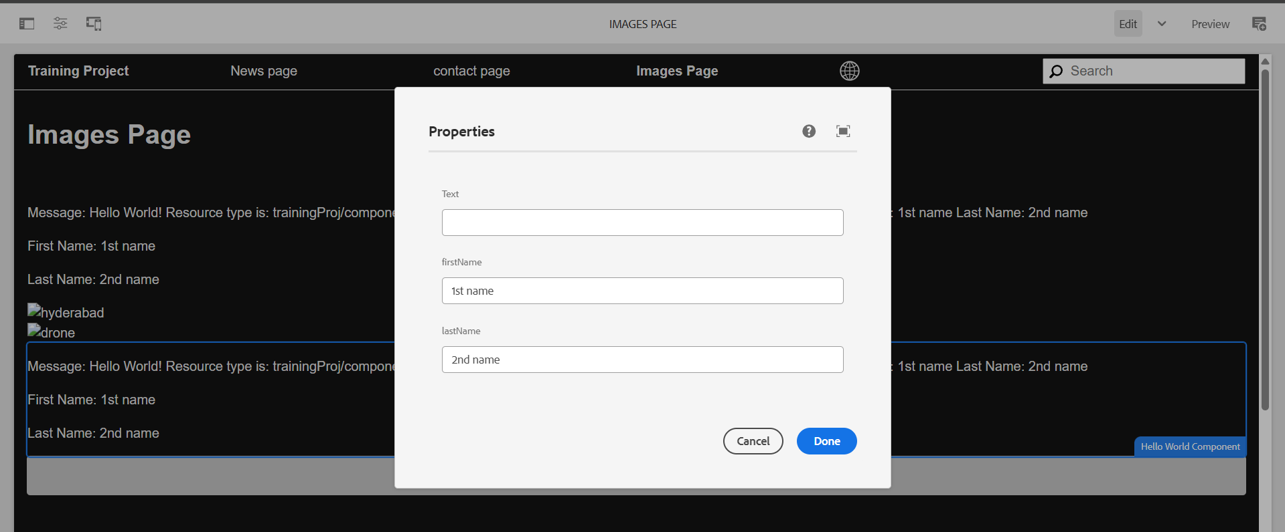

**Why We Use Package Manager and JAR in AEM?**

**🔹 Package Manager**

* Purpose: Used to package, install, and manage AEM content, including components, templates, configurations, and code.
* Why?
  + Helps move content between environments (Dev → QA → Prod).
  + Allows versioning and rollback of packages.
  + Provides easy deployment of custom components.

**🔹 JAR (Java Archive)**

* Purpose: AEM itself runs as a JAR file (aem-quickstart.jar).
* Why?
* AEM is a Java-based application, so it’s bundled as a JAR.
* Custom OSGi bundles (for backend logic) are deployed as JARs in /apps/myproject/install.
* Java libraries used in AEM are packaged as JARs for reusability.

**create package for the hello world component and 2 images what we have uploaded**

There should be 2 packages 1 for dam which is images and 2 one is for helloworld component

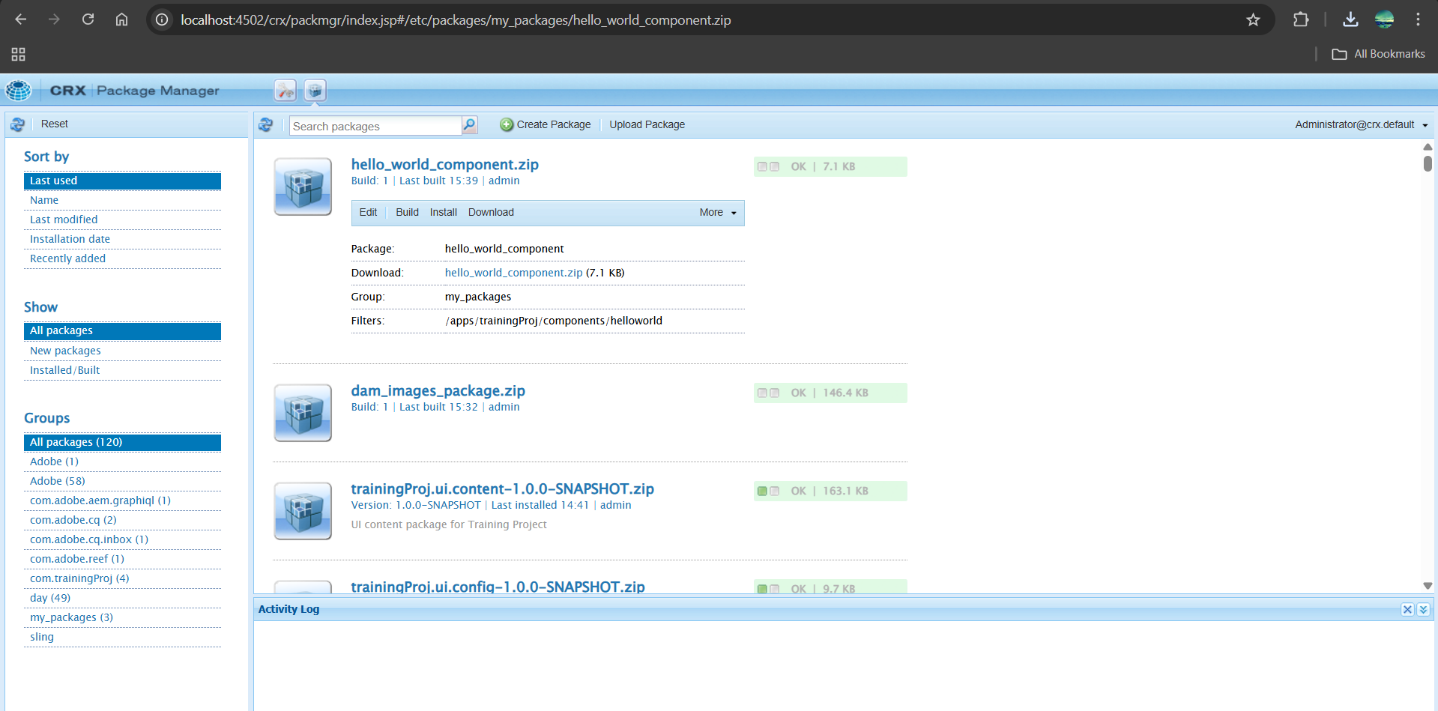

**7. Configure replication agent and publish the page from author to publish env(4502(author)—>4503(publish))**

